2a. 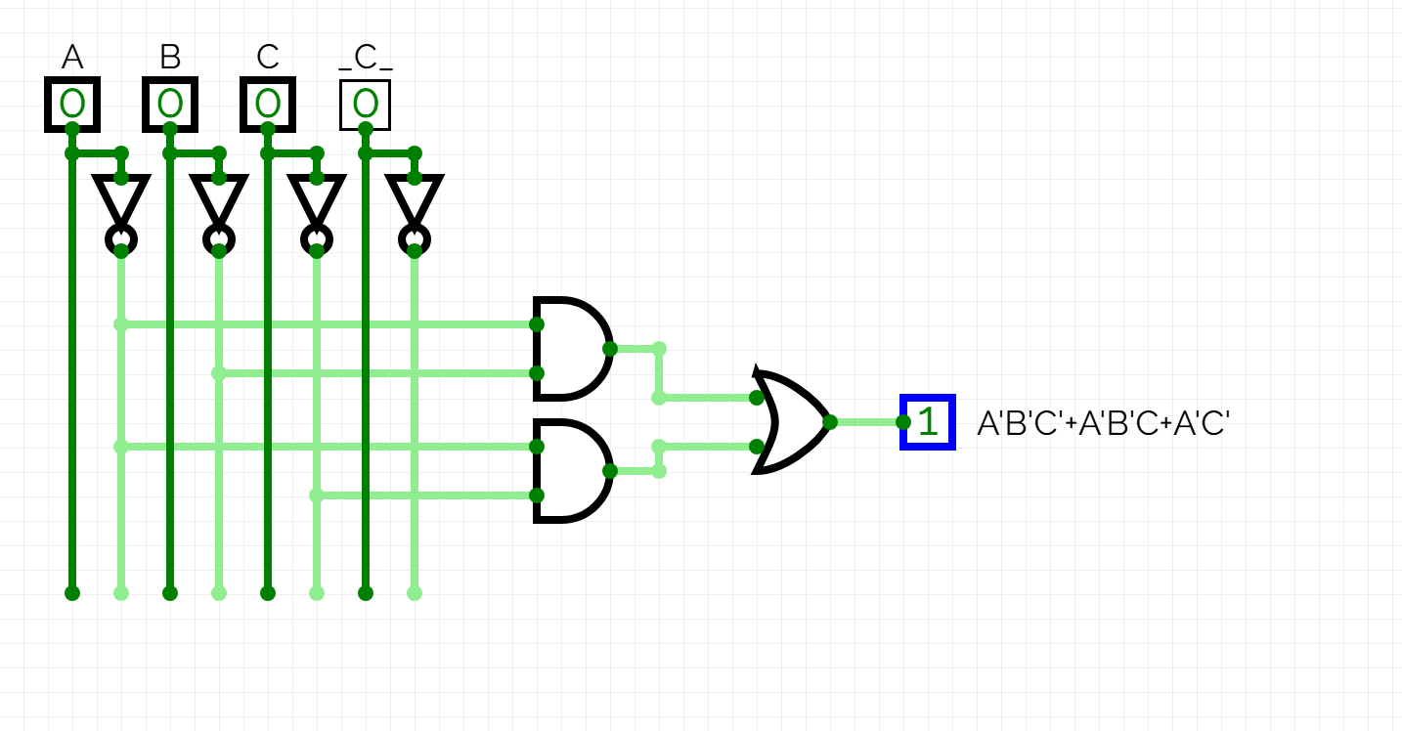
The equation simplifies to ${(C}^{'}+B)*A$
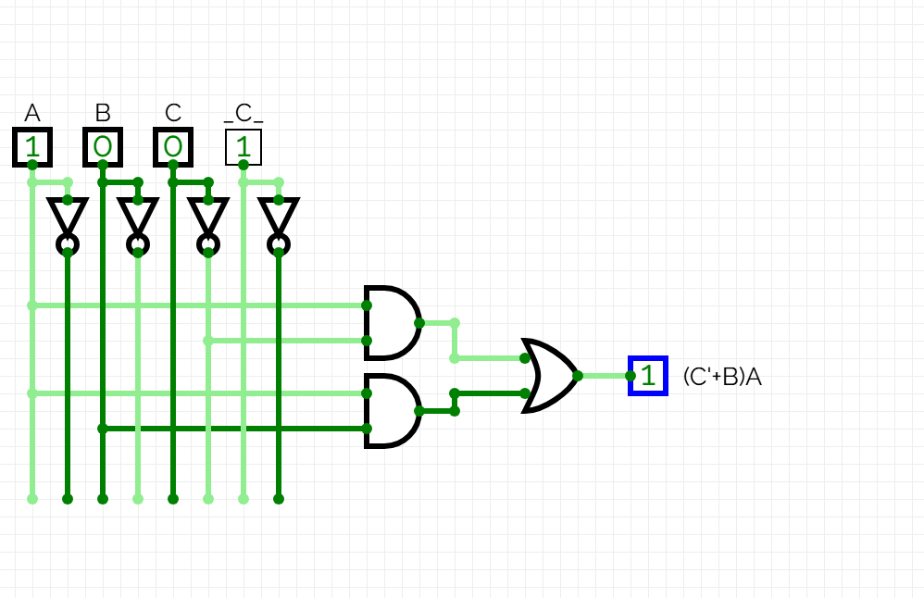

2b.
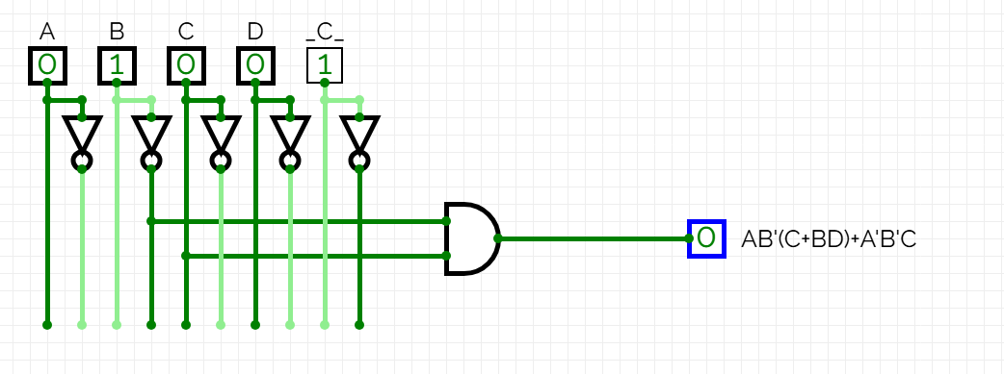
Simplfies to: $\left(A*B^{'}\right)+C+(B*D)$
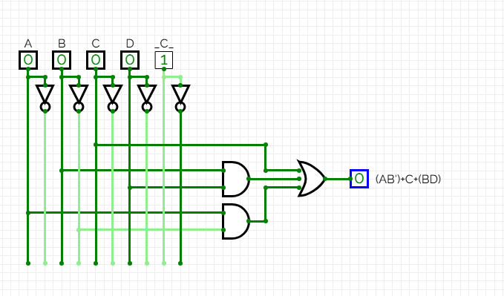

3a.
A/BC | 00 | 01 | 11 | 10
0 | 1 | 1 | 1 | 1
1 | 0 | 0 | 1 | 0

3b. Our equation once again simplifies to $BC+A'$

